**iS3 详细设计规约**

小组成员 1751062 陈恬恬

1752461 刘雨

1754067 徐海琪

# 修订历史

|  |  |  |  |  |  |  |  |  |
| --- | --- | --- | --- | --- | --- | --- | --- | --- |
| 编写日期 | SEPG | 版本 | 说明 | 作者 | 评审时  间 | 参与人  员 | 批准日  期 | 确认人  员 |
| 2019-12-04 | iS3 | 1.0 | 初稿 | 刘雨 |  |  |  |  |
| 2019-12-30 | iS3 | 2.0 | 模块 | 刘雨、徐海琪 |  |  |  |  |
| 2020-01-06 | iS3 | 3.0 | 定稿 | 刘雨、陈恬恬 |  |  |  |  |

# 目录

修改历史 2

1 引言 4

1.1 编写目的 4

1.2 背景与依据 4

1.3 参考资料 4

2 系统软件结构 4

3 核心类 4

3.1 类描述 5

3.2 功能 5

3.3 详细设计 5

3.3.1 Project详细设计 5

3.3.2 ProjectDefinition详细设计 7

3.3.3 ProjectList详细设计 8

3.3.4 Domain详细设计 9

3.3.5 DGObjects详细设计 11

3.3.6 DGObject详细设计 12

4 类图 13

4.1 类描述 13

4.2 功能 13

4.3 类详细设计 13

4.3.1 UserLoginPage详细设计 13

4.3.2 ProjectListPage详细设计 17

4.3.3 MainFrame详细设计 19

4.3.4 PlanView&IS3View详细设计 22

4.3.5 IS3DataGrid详细设计 24

4.3.6 ConfPathWindow详细设计 25

4.3.7 ProjectsWindow详细设计 27

4.3.8 ProjGnrDefWindow详细设计 29

4.3.9 ProjEMapDefWindow详细设计 31

4.3.10 ProjDomainDefWindow详细设计 33

4.3.11 ProjTreeDefWindow详细设计 35

5 控制类 36

5.1 描述 36

5.2 功能 36

5.3 模块详细设计 36

5.3.1 ProjectController详细设计 36

5.3.2 MonitoringController详细设计 4

# 1 引言

1.1 编写目的

《详细设计书》是项目设计的第二个阶段，这个阶段的主要任务是在《概要设计书》基础上， 对概要设计中产生的功能模块进行过程描述，设计功能模块的内部细节，包括类的详细逻辑和接口及类之间的调用关系，为编写源代码提供必要的说明。

本文档的目的旨在推动软件工程的规范化，使设计人员遵循统一的详细设计书写规范，节省制作文档的时间，降低系统实现的风险，做到系统设计资料的规范性与全面性，以利于系统的实现、测 试、维护、版本升级等。

概要设计解决了软件系统总体结构设计的问题，包括整个软件系统的结构、模块划分、模块功能和模块间的联系等。详细设计则要解决如何实现各个模块的内部功能，即模块设计。具体的说，模块设计就是要详细描述各模块中包含的类的处理逻辑及其提供接口的参数格式、请求方式。但这并不等同于系统实现阶段用具体的语言编码，它只是对实现细节作精确的描述，这样编码阶段就可以将详细设计中对功能实现的描述，直接翻译、转化为用某种程序设计语言书写的程序。详细设计的详细程度，应达到可以编写程序的水平。

1.2 背景与依据

iS3平台是地下工程管理平台，可以对地下工程整个生命周期的数据进行采集、管理、可视化和分析。本文档依据《需求分析规约》。

1.3 参考资料

［1］iS3 概要设计规约（说明书）［2016-01－13］

［2］GB8567-88，计算机软件产品开发文件编制指南

# 2 系统软件结构

见《需求分析规约》第 2.1 节。

# 3 核心类

3.1 描述

核心类存储所有的非图形信息。是MVC设计模式的Model。核心类由Project为基础，存储

所有非图形信息。Project由ProjectDefinition和Domain组成，ProjectDefinition定义项目信

息，所有工程数据存储在Domain中，

3.2 功能

（1）存储数据。

（2）从数据库中加载数据。

（3）从本地文件加载信息。

3.3 类详细设计

Project详细设计

类图

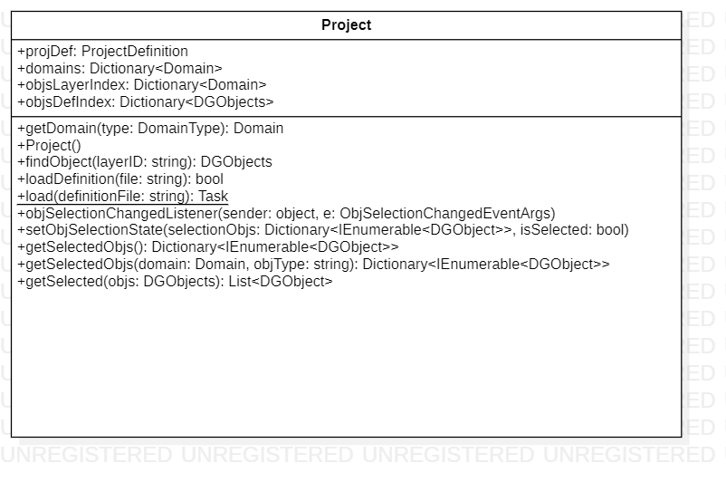

属性及方法描述

|  |  |  |  |
| --- | --- | --- | --- |
| Class Project | 变量 | ProjectDefinition projDef | 工程定义 |
| Dictionary<string, Domain> _domains | 工程 domain 索引 |
| Dictionary<string, DGObjects> objsLayerIndex | 图层名和对象索引 |
| Dictionary<DataSet, DGObjects> dataSetIndex | Dataset 和对象的索引 |
| 方法 | Domain this[string key] | 返回关键字的 domian |
| Domain getDomain(DomainType type) | 返回对应类型的 domain |
| DGObjects findObjects(string layerID) | 找到指定图层上的对象 |
| bool loadDefinition(string file) | 加载工程定义文件 |
| int syncObjectsOnTree  (Tree inputTree, bool readSubTree = true) | 同步数据树和对象，返回  同步类型数 |
| static Project load  (string definitionFile) | 加载 Project |
| void objSelectionChangedListener(object  sender, ObjSelectionChangedEventArgs e) | 对象选取更改事件监听 |
| setObjSelectionState  (Dictionary<string, IEnumerable<DGObject>> selectedObjs,bool isSelected) | 设置指定对象选取状态 |
| Dictionary<string, IEnumerable<DGObject>>  getSelectedObjs() | 获取当前选择的所有对象 |
| Dictionary<string, IEnumerable<DGObject>> getSelectedObjs  (Domain domain, string ObjType) | 获取指定 domain，objType  下的选取对象 |
| List<DGObject> getSelected(DGObjects objs) | 获取对象组中的选取对象 |

1752461 刘雨

核心方法实现流程

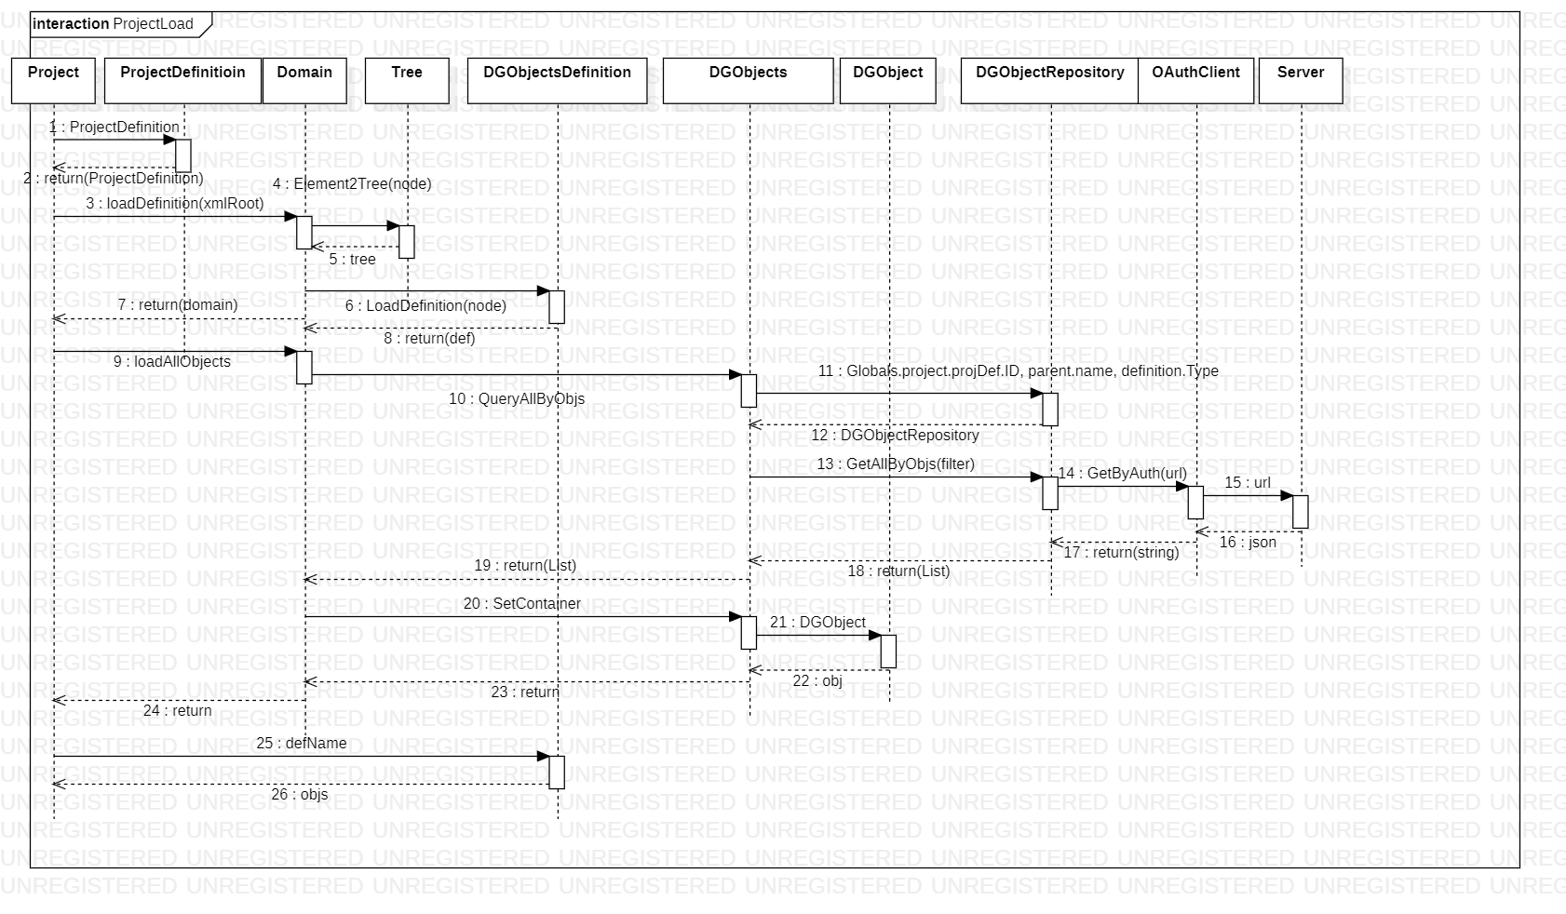

类内、类外方法调用状态图

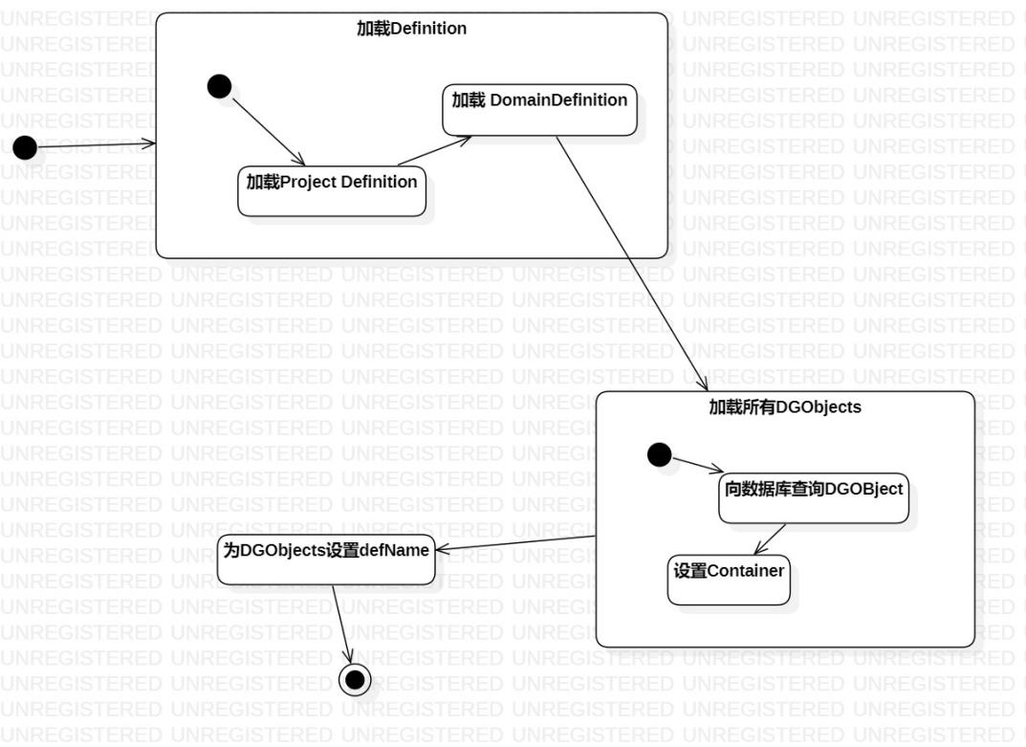

ProjectDefinition类详细设计

类图

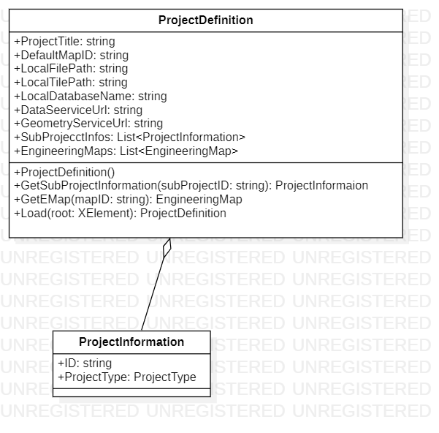

属性及方法描述

|  |  |  |  |
| --- | --- | --- | --- |
| class ProjectDefinition | 变量 | string ID | 工程 ID |
| string ProjectTitle | 工程名称 |
| string DefaultMapID | 默认图层 ID |
| string LocalFilePath | 文件目录 |
| string LocalTilePath | TPK 文件目录 |
| string LocalDatabaseName | 数据库文件名称 |
| string DataServiceUrl | 数据服务 URL |
| string GeometryServiceUrl | 地图服务 URL |
| List<ProjectInformation> SubProjectInfos | 子工程信息 |
| List<EngineeringMap> EngineeringMaps | 工程地图索引 |
| 方法 | ProjectInformation GetSubProjectInformation  (string subProjectID) | 获取子工程信息 |
| EngineeringMap GetEMap(string mapID) | 获取相应的工程地图 |
| static ProjectDefinition Load  (XElement root) | 从工程 XML 文件加载工程  定义 |

核心方法实现流程

同图 3.3.1.3

类内、类外方法调用状态图

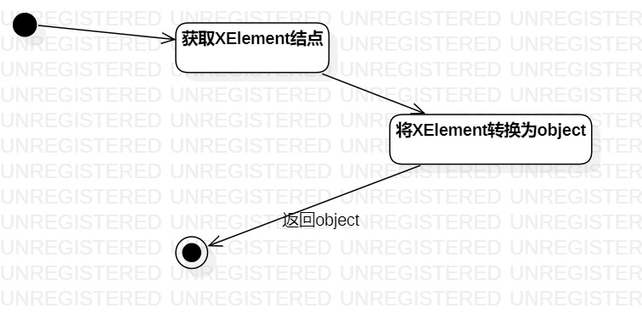

* + 1. ProjectList详细设计

类图

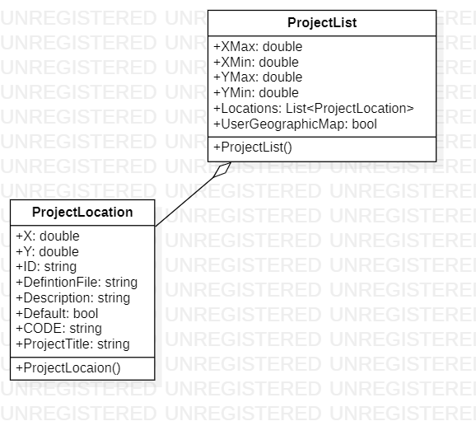

* + 1. Domain详细设计
       1. 类图

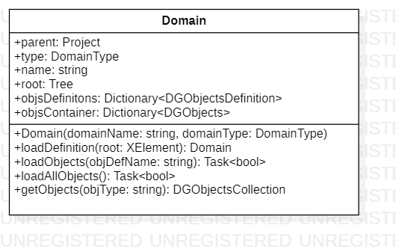

属性及方法描述

|  |  |  |  |
| --- | --- | --- | --- |
| class Domain | 变量 | Project parent | 所属的项目 |
| DomainType type | 所属的Domain类型 |
| string name | Domain名称 |
| Tree root | 根结点 |
| Dictionary<DGObjectsDefinition> objsDefinitions | 所拥有的DGObjects的定义 |
| Dictionary<DGObjects> objsContainer | 存放拥有的所有DGObjects |
| 方法 | Domain(string domainName,DomainType domainType) | 构建Domain |
| loadDefinition(XElement root) | 加载Domain的定义 |
| LoadObjects(string objDefName) | 加载所有DGObjects |

类核心方法流程

同图 3.3.1.3

类内、类外方法调用状态图

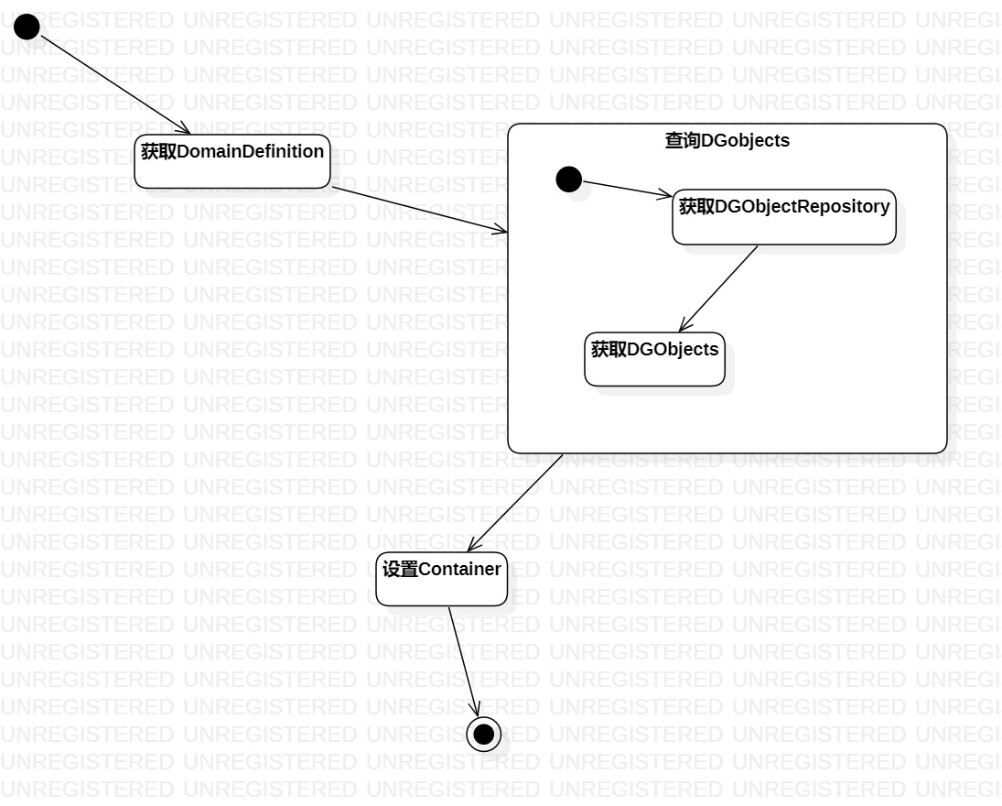

* + 1. DGObjects详细设计

类图

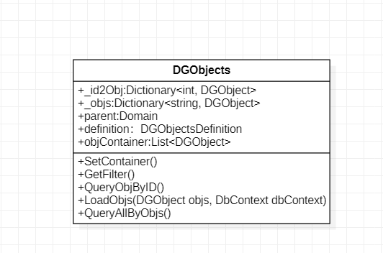

属性及方法描述

|  |  |  |  |
| --- | --- | --- | --- |
| class DGObjects | 变量 | Domain parent | 对象组的父节点 |
| DGObjectsDefinition definition | 对象组的定义 |
| List<DGObject> | 对象组的源数据 |
| Dictionary<string, DGObject> _objs | 数据行和对象索引 |
| Dictionary<int, DGObject> _id2Obj | 对象和数据行索引 |
| 方法 | SetContainer() | 设置存储DGObject的容器 |
| QueryObjByID() | 获取 id 对应的对象 |
| loadObjs() | 加载所有对象 |

核心方法流程

同图 3.3.1.3

类内、类外方法调用状态图

DGObject详细设计

类图

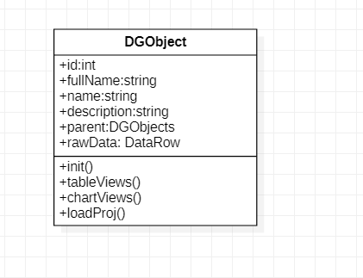

属性及方法描述

|  |  |  |  |
| --- | --- | --- | --- |
| class DGObject | 变量 | int id | 对象 ID |
| string name | 对象名称 |
| string fullName | 对象全称 |
| string description | 对象描述 |
| DataRow rawData | 对象对应的数据行 |
| 方法 | virtual bool LoadObjs(DGObjects objs) | 加载数据库到对象 |
| virtual List<DataView>  tableViews(IEnumerable<DGObject> objs) | 对象对应的表视图 |
| virtual List<FrameworkElement> chartViews  ( IEnumerable<DGObject> objs, double width, double height) | 对象对应的图视图 |

# 4 界面类

4.1 描述

界面类使用了C#的WPF框架，每个类对应一个页面（.xaml文件），用于实现页面的业务逻辑。核心的MainFrame类继承了IMainFrame接口， 属于MVC的 Controller层。

4.2 功能

1. 登录；
2. 配置Server端IP及端口；
3. 管理项目列表信息；
4. 查看项目地址信息；
5. 查看项目图层信息；
6. 查看项目数据组信息；
7. 配置项目定义信息；
8. 配置项目图层信息；
9. 配置项目Domain信息；
10. 配置项目数据组信息；
11. 配置项目树；

4.3 类详细设计

UserLoginPage详细设计

类图

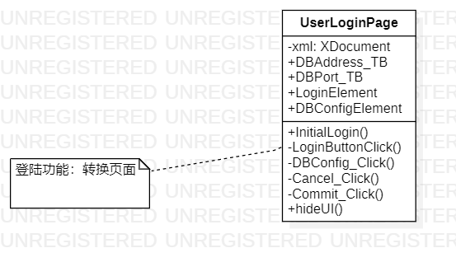

类属性及方法描述

|  |  |  |  |
| --- | --- | --- | --- |
| class UserLoginPage | 变量 | XDocument xml | 配置信息xml文件 |
| string DBAddress_TB | Server端IP |
| string DBPort_TB | Server端端口 |
| UserControl LoginElement | 登录组件 |
| UserControl DBConfigElement | 配置组件 |
| 方法 | LoginButton_Click(object sender, RoutedEventArgs e) | 登录 |
| DBConfig_Click(object sender, RoutedEventArgs e) | 切换配置组件 |
| Cancel_Click(object sender, RoutedEventArgs e) | 取消配置 |
|  |  | Commit_Click(object sender, RoutedEventArgs e) | 提交配置 |

类核心方法流程

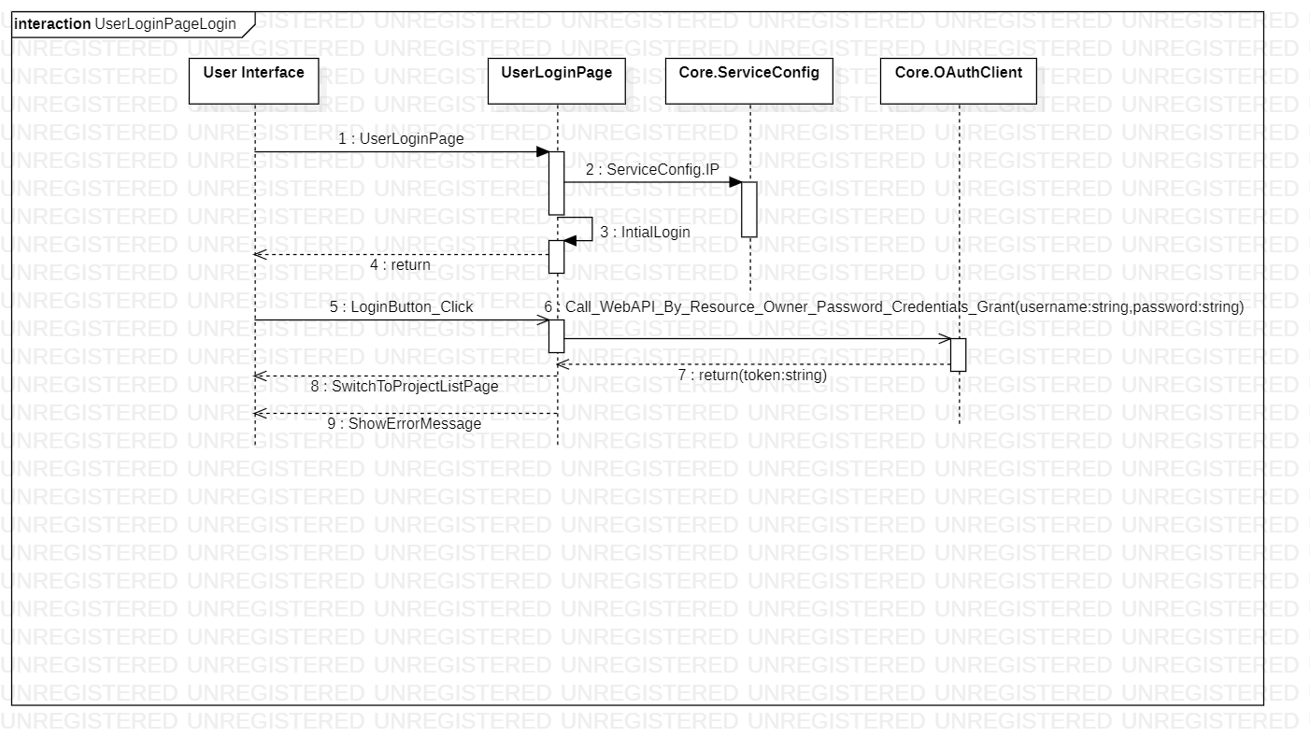

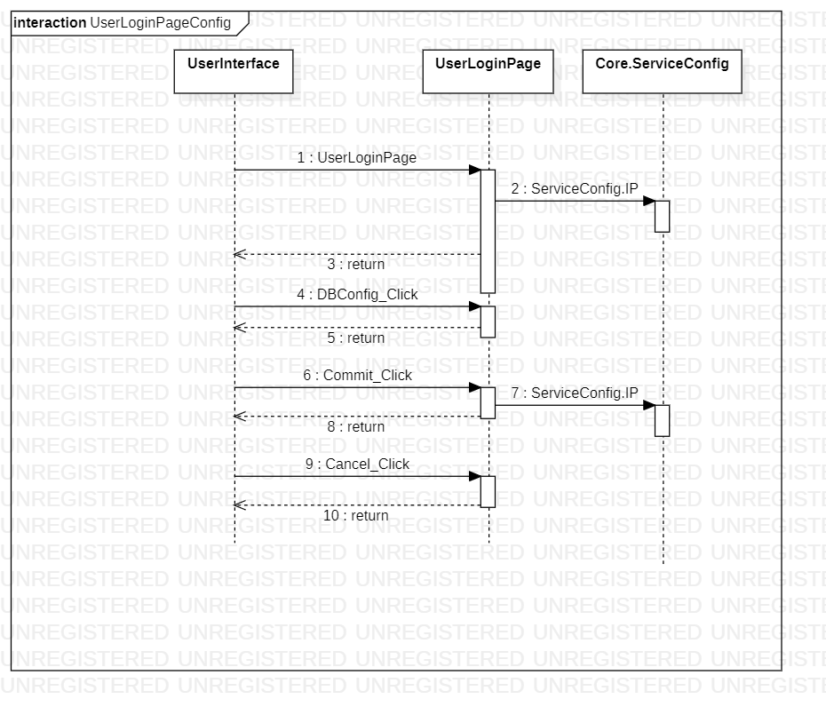

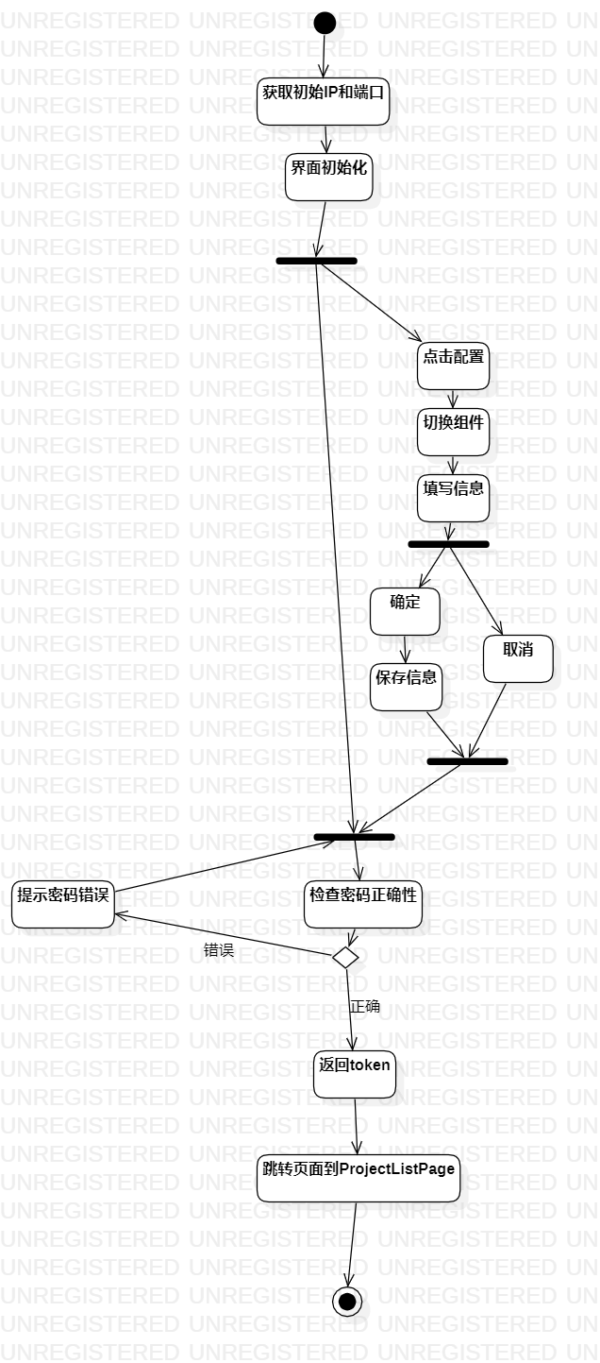

ProjectListPage详细设计

图

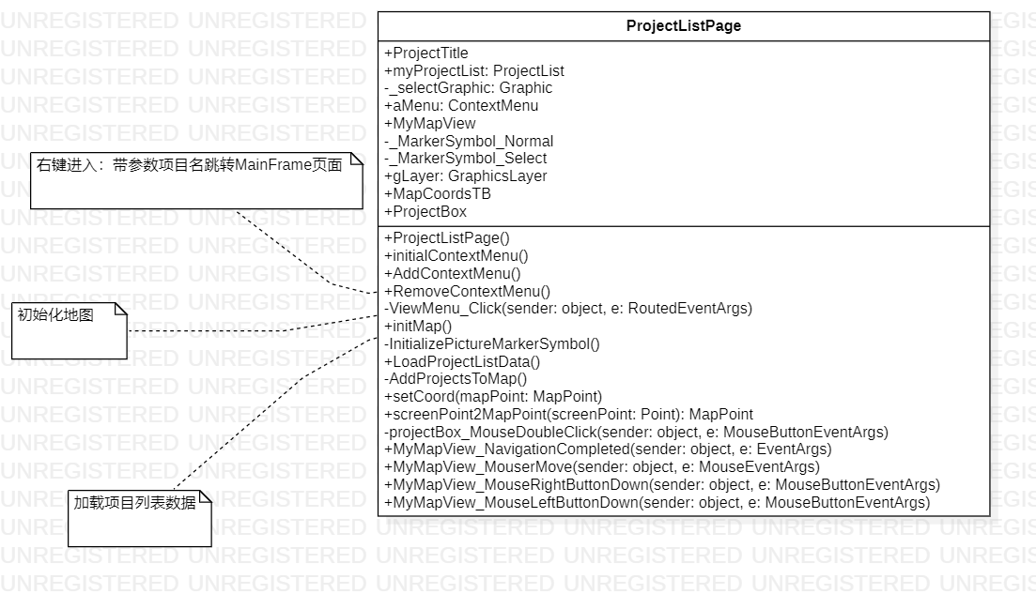

类属性及方法描述

|  |  |  |  |
| --- | --- | --- | --- |
| class ProjectListPage | 变量 | ProjectList myProjectList | 项目列表 |
| string ProjectTitle | 项目名 |
| PictureMarkerSymbol _MarkerSymbol_Normal | 平常状态图标 |
| PictureMarkerSymbol _MarkerSymbol_Select | 中状态图标 |
| UserControl ProjectBox | 项目列表组件 |
| 方法 | LoadProjectListData() | 加载项目列表数据 |
| AddProjectsToMap() | 添加项目到地图上 |
| initMap() | 初始化地图事件 |
|  |  | InitializePictureMarkerSymbol() | 初始化地图图标 |

类核心方法流程

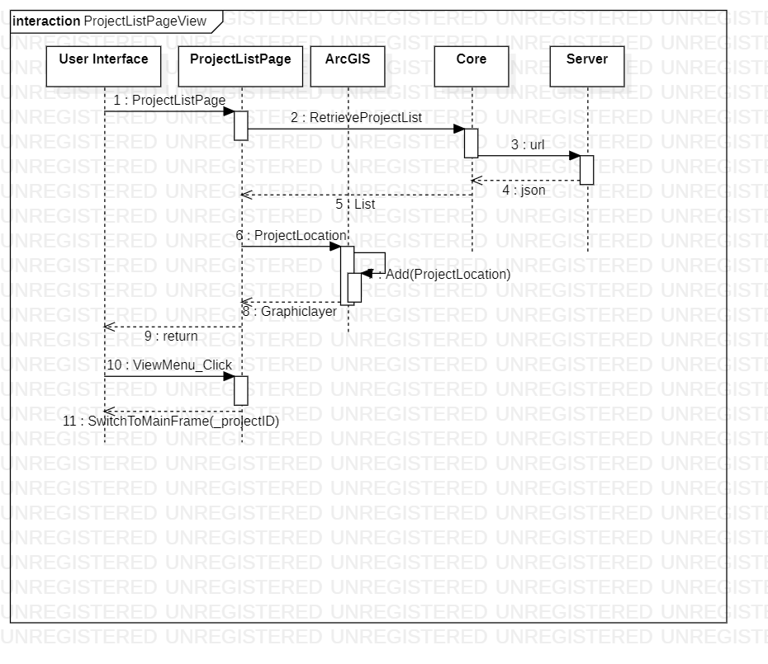

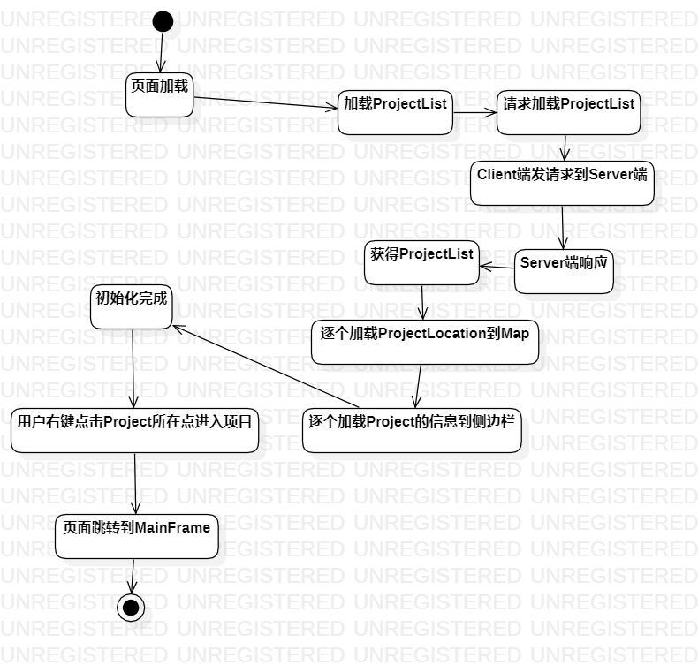

MainFrame详细设计

类图

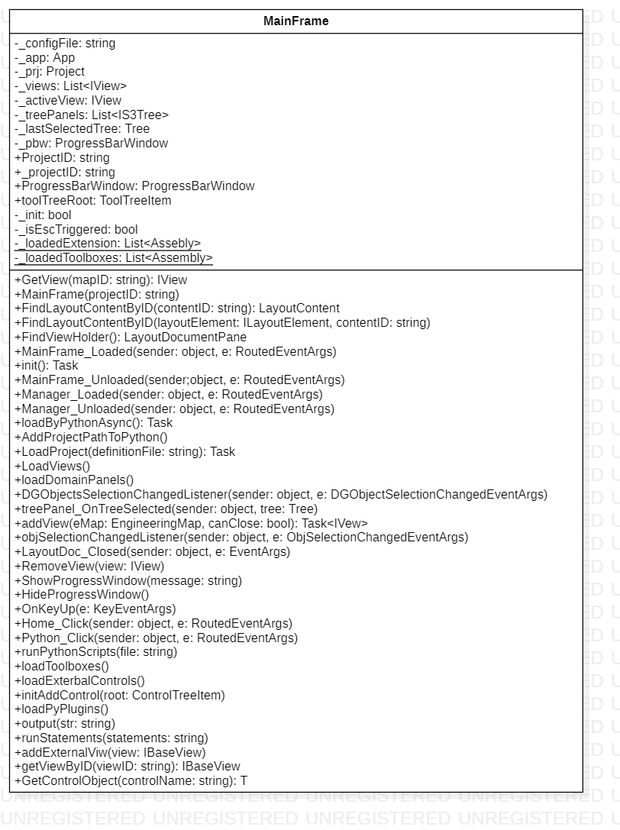

类属性及方法描述

|  |  |  |  |
| --- | --- | --- | --- |
| class MainFrame | 变量 | string _configFile | 配置信息xml文件 |
| Project _prj | 项目 |
| UserControl PlanView | ViewHolder,视图渲染组件 |
| UserControl DataGrid | 原始数据展示组件 |
| UserControl TreePanel | 项目结构树选择组件 |
| 方法 | LoadProject(string definitionFile) | 加载项目 |
| LoadView() | 加载视图 |
| loadExtensions(); | 加载拓展库 |
|  |  | loadPyPlugins(); | 加载python插件 |

类核心方法流程

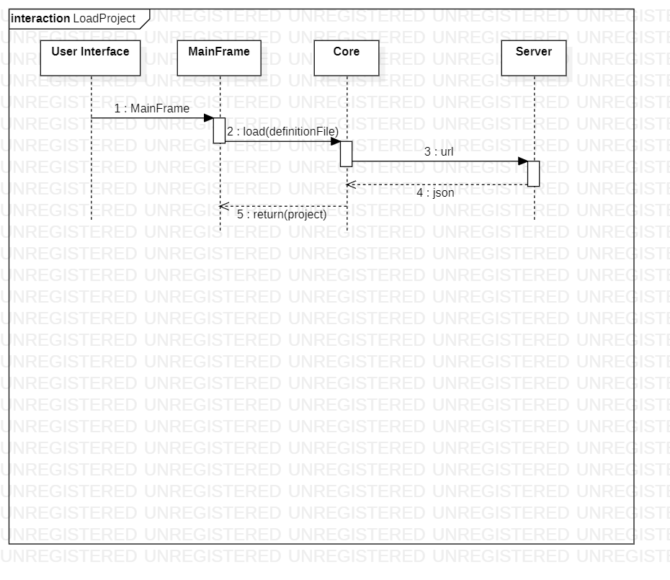

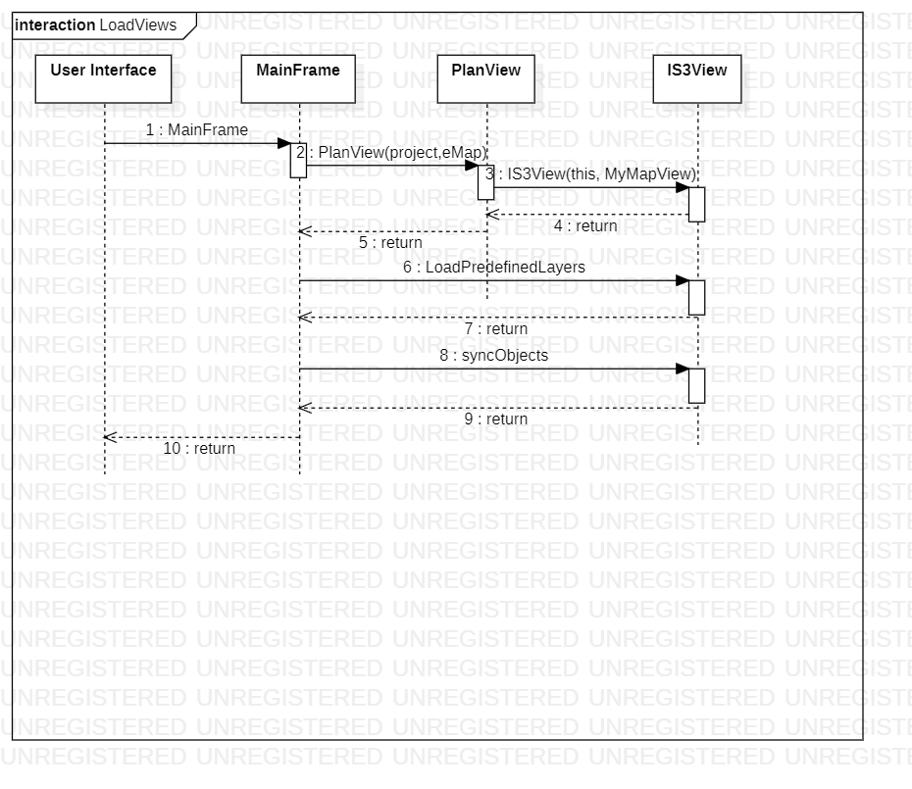

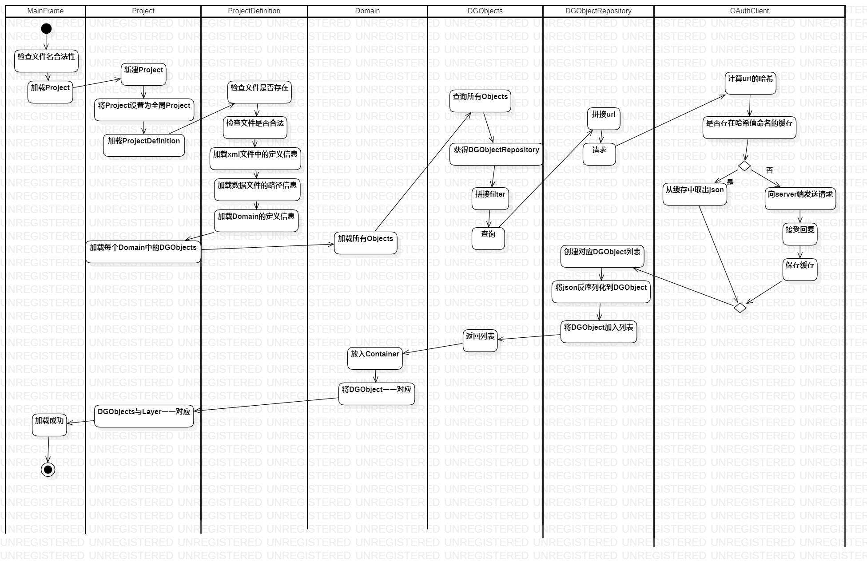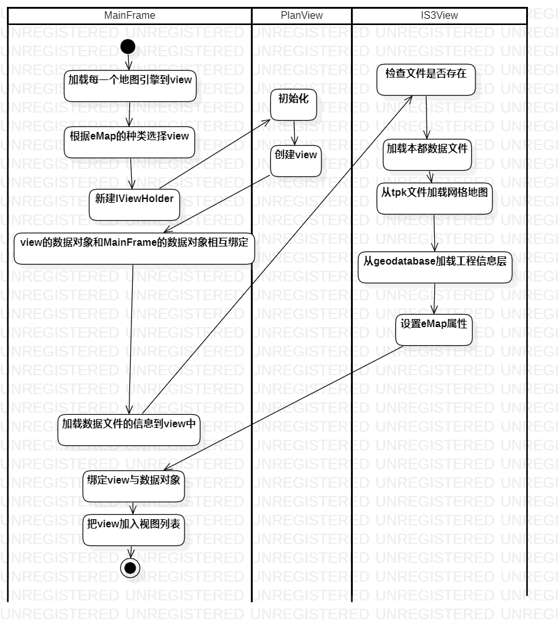

PlanView&IS3View详细设计

类图

PlanView:

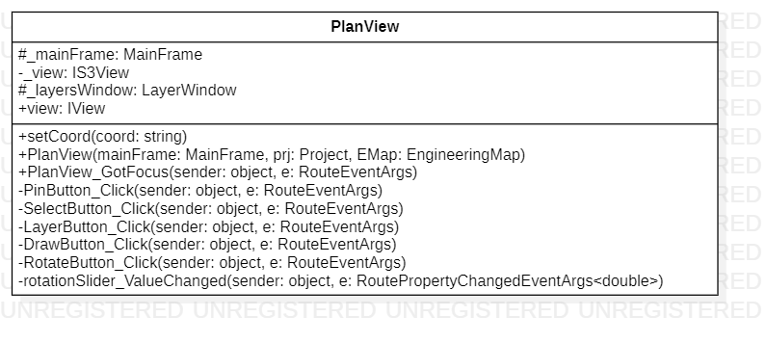

IS3View:

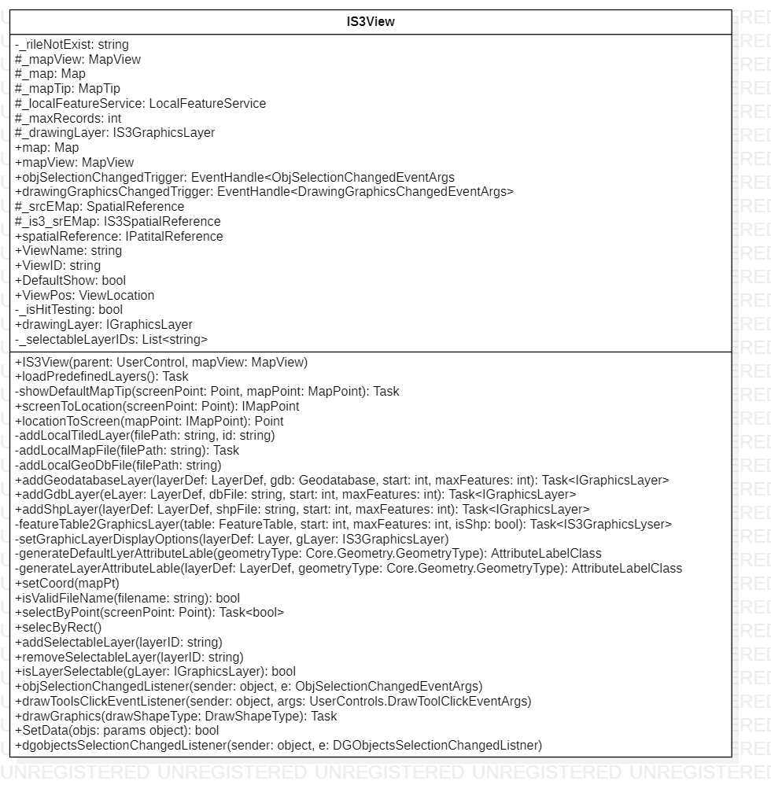

类属性及方法描述

|  |  |  |  |
| --- | --- | --- | --- |
| class PlanView | 变量 | UserControl _mainFrame | 主框架 |
| IS3View _view | 图层 |
| 方法 | SelectButton_Click(object sender, RoutedEventArgs e) | 选择按钮事件 |
| LayersButton_Click(object sender, RoutedEventArgs e) | 图层按钮事件 |
| DrawButton_Click(object sender, RoutedEventArgs e) | 绘制按钮事件 |
|  |  | RotateButton_Click(object sender, RoutedEventArgs e) | 旋转按钮事件 |
| class IS3View | 变量 | Map map | GIS地图 |
| MapView mapView | GIS地图图层 |
| 方法 | objSelectionChangedListener(object sender,  ObjSelectionChangedEventArgs e) | 数据对象变化监听器被触发事件 |
| loadPredefinedLayers() | 加载预先设定层 |
| showDefaultMapTip(Point screenPoint, MapPoint mapPoint) | 渲染默认地图 |
|  |  | addGeodatabaseLayer(LayerDef layerDef,Geodatabase gdb, int start = 0, int maxFeatures = 0) | 添加地质数据层 |

类核心方法流程

见图4.3.3.3

类内、类外调用状态图

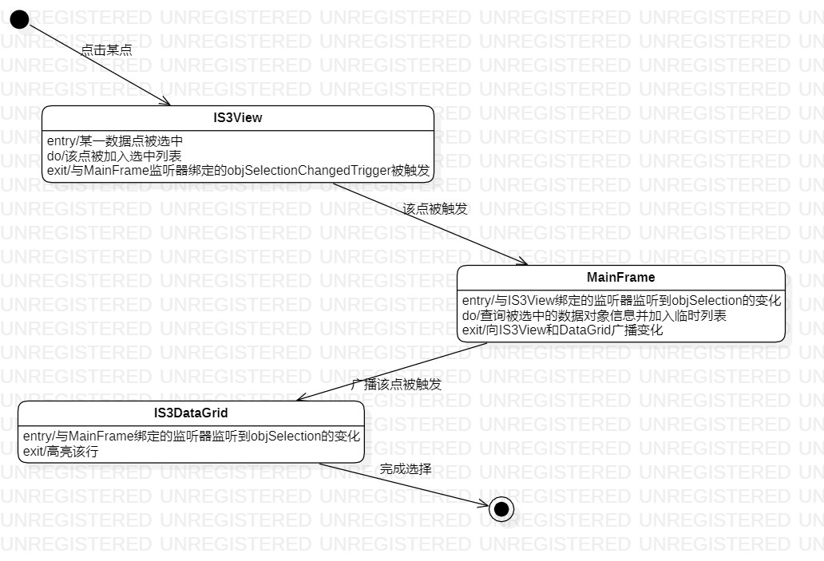

IS3DataGrid详细设计

类图

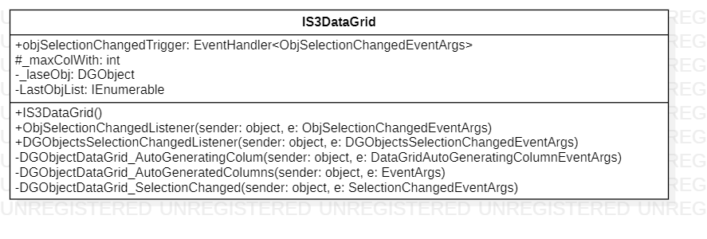

类核心方法流程

见图4.3.3.3

类内、类外调用状态图

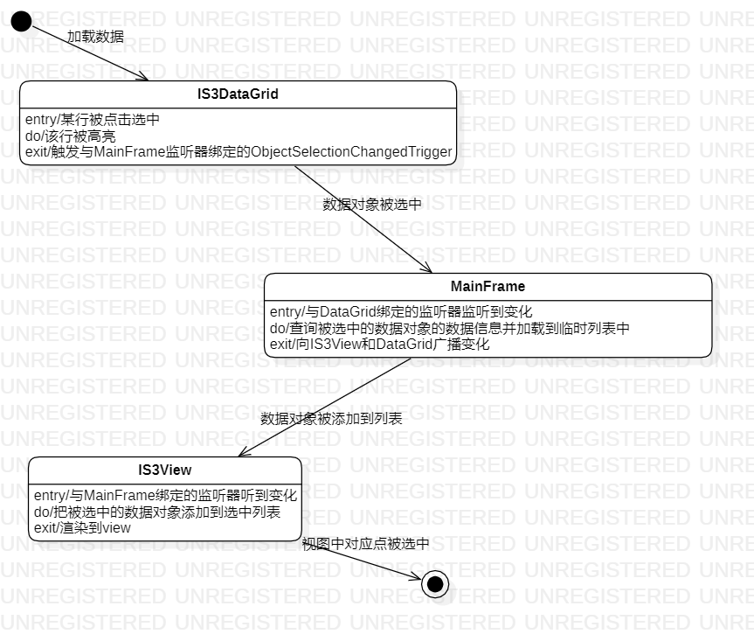

ConfPathWindow详细设计

类图

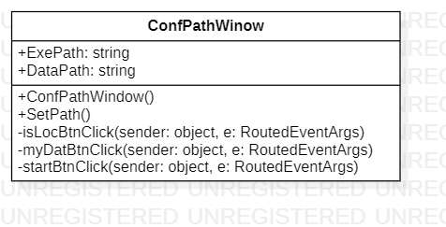

类核心方法流程

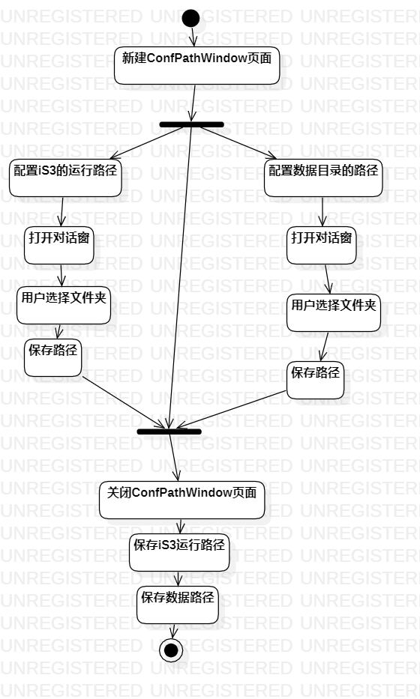

ProjectsWindow详细设计

类图

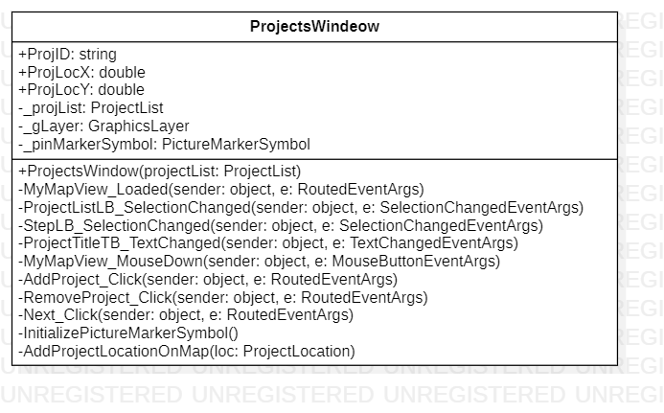

类核心方法流程

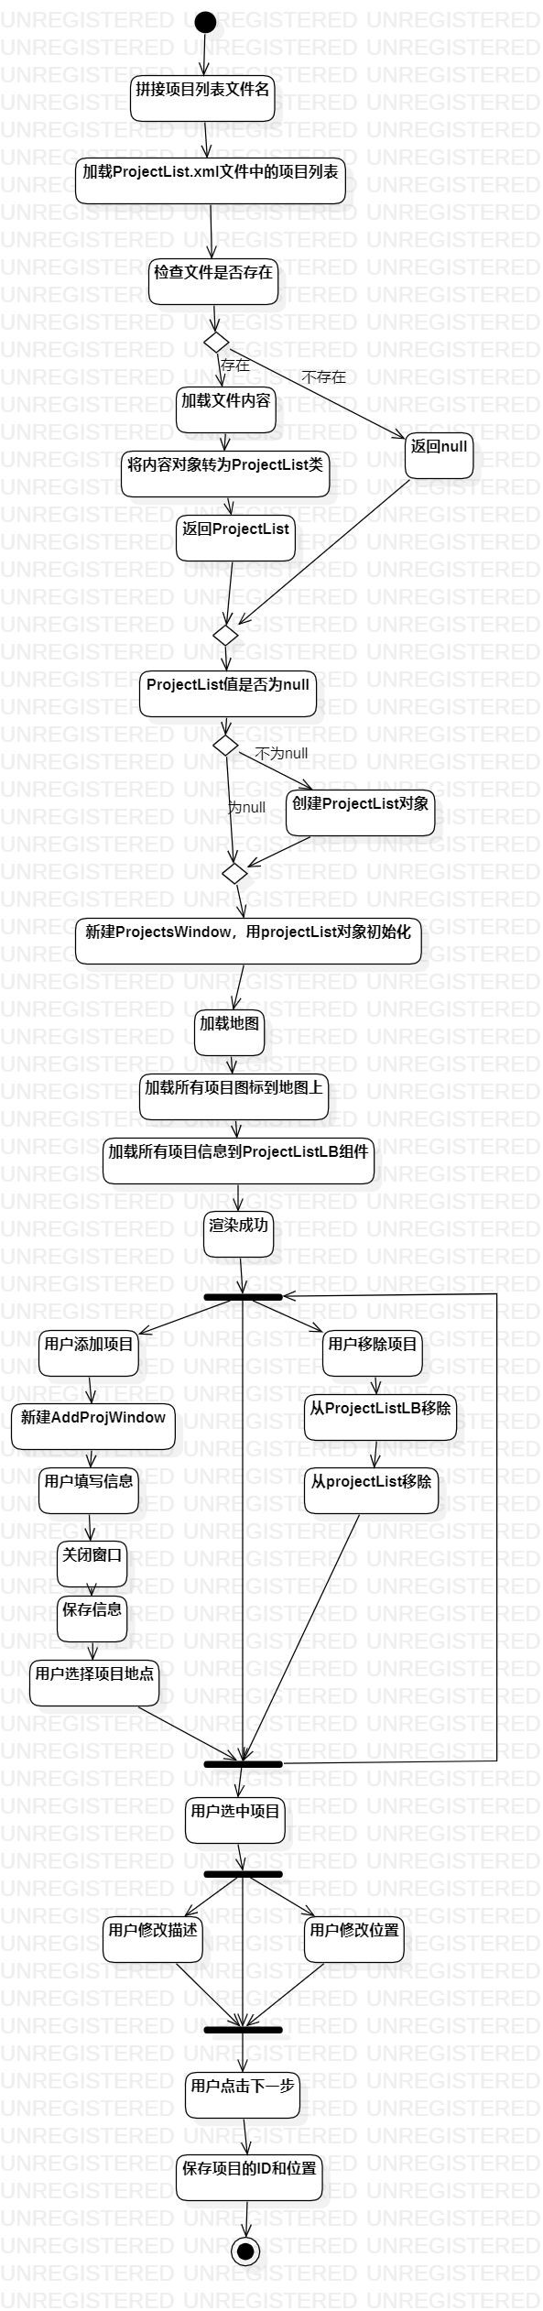

ProjGnrDefWindow详细设计

类图

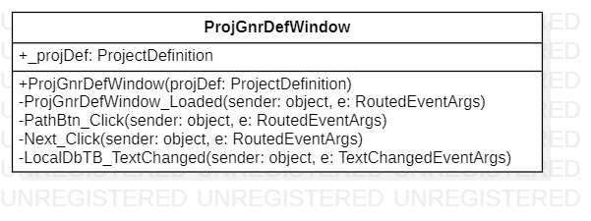

类核心方法流程

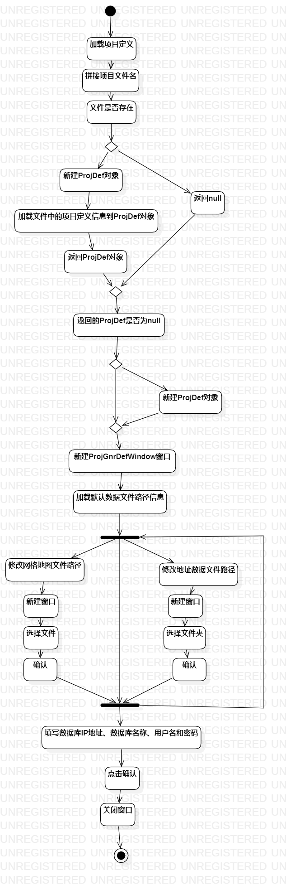

ProjEMapDefWindow详细设计

类图

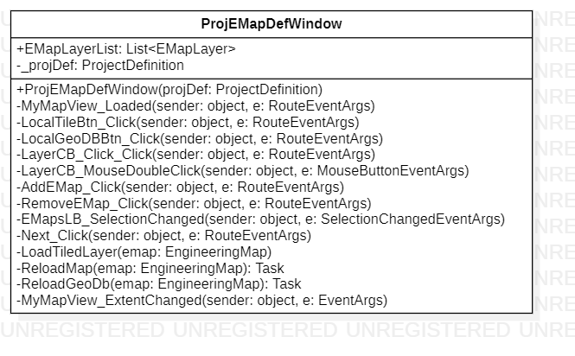

类核心方法流程

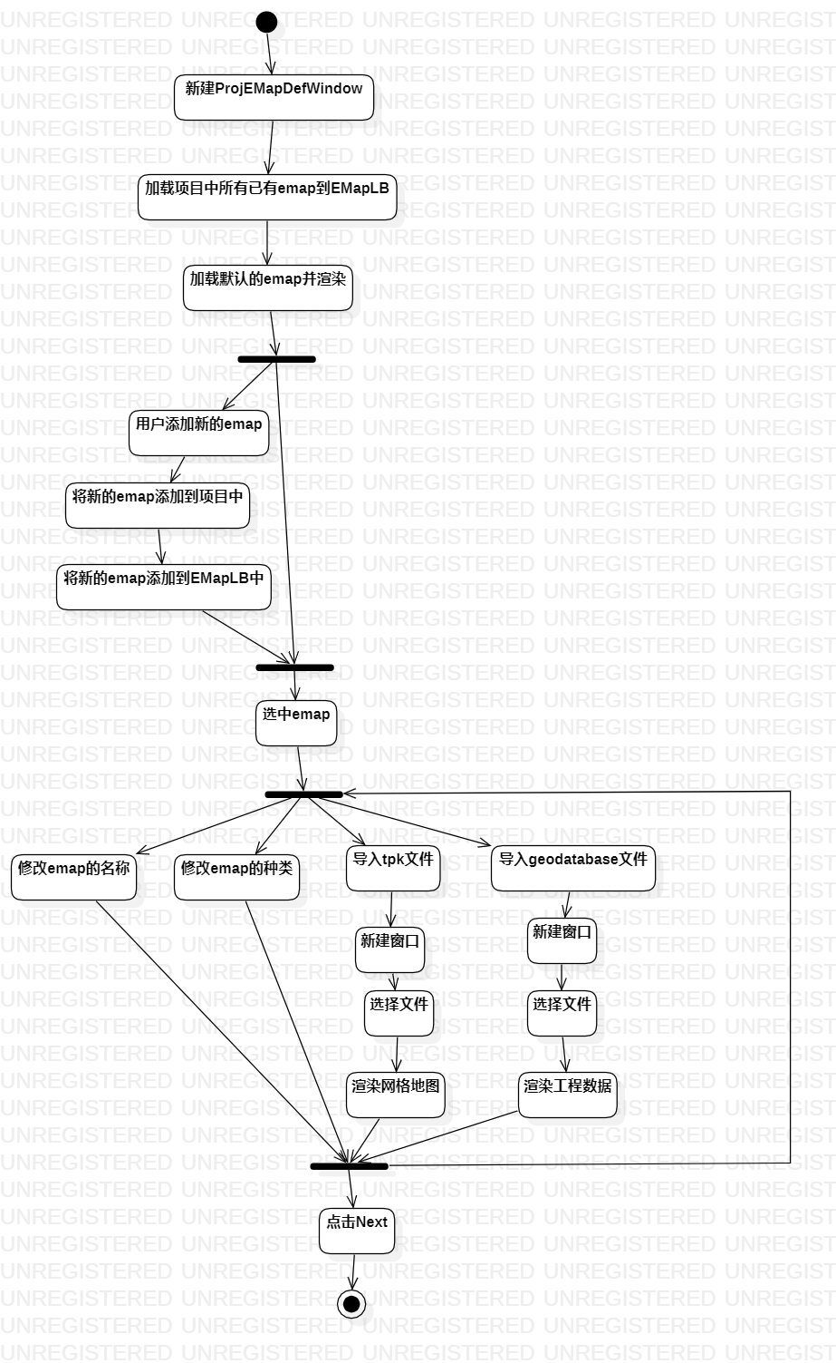

ProjDomainDefWindow详细设计

类图

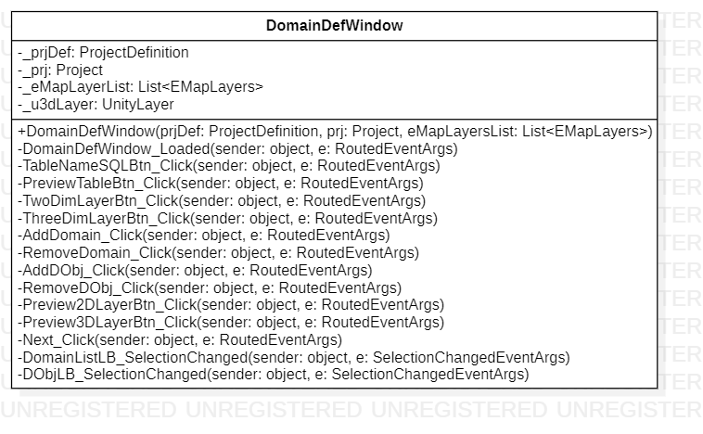

类核心方法流程

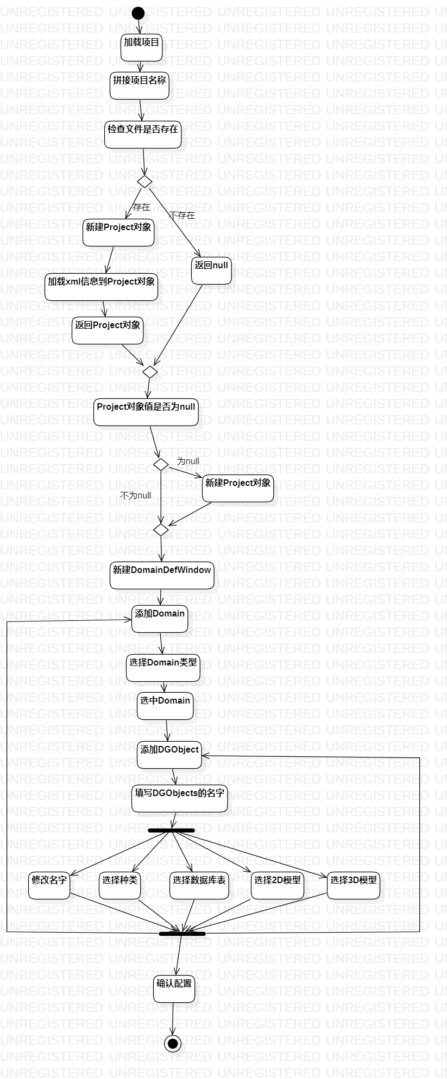

ProjTreeDefWindow详细设计

类图

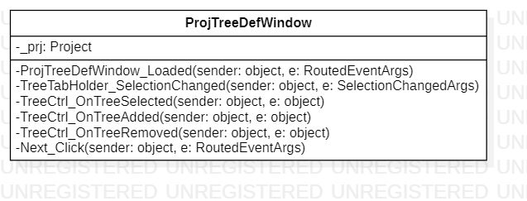

类核心方法流程

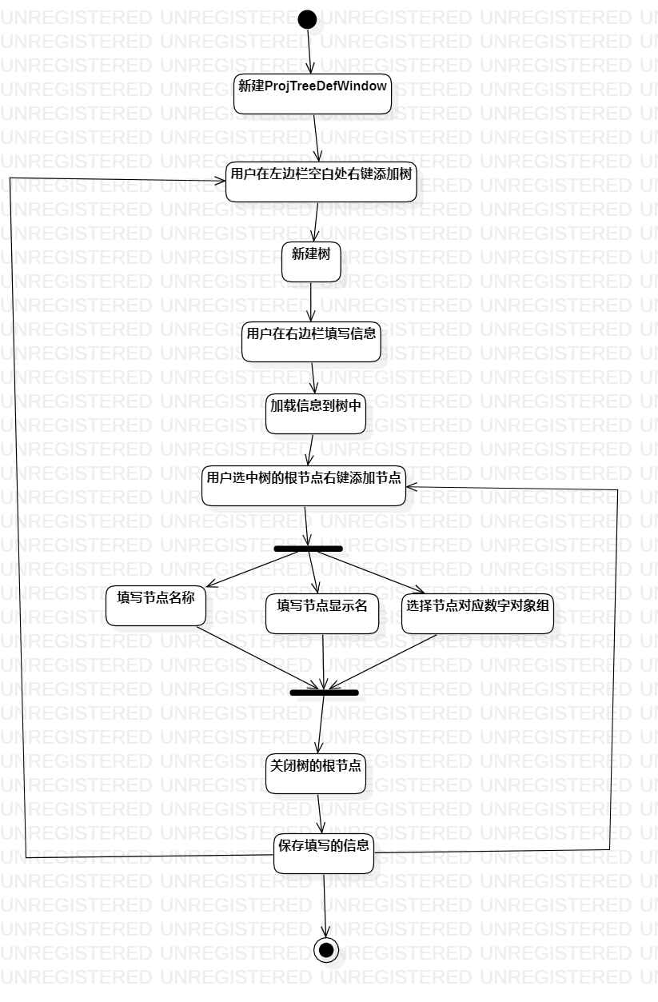

5 控制类

5.1 描述

分为ProjectController,GeologyController,MonitoringController三部分。

5.2 功能

1. 获取Project的数据
2. 获取Geology的数据
3. 获取Monitoring的数据

5.3 模块详细设计

ProjectController详细设计

输入项

①code ：由 HttpRequest 获得

逻辑流程图

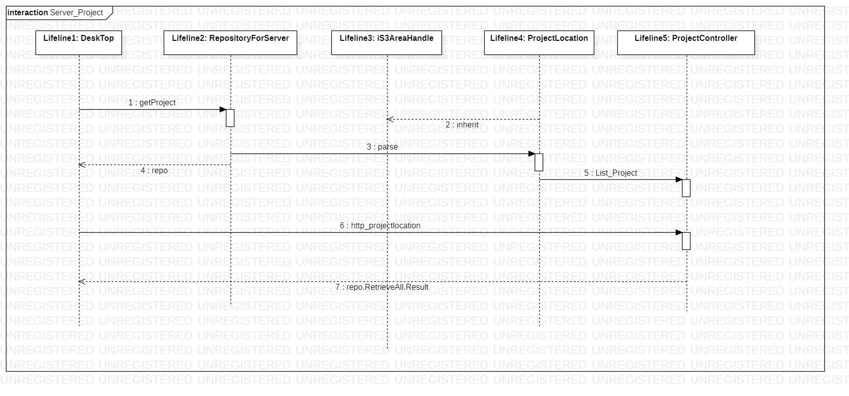

接口

|  |  |  |  |
| --- | --- | --- | --- |
| 请求地址： | /api/project/projectlocation | | |
| 请求方式： | GET | | |
| 请求参数： | 字段 | 类型 | 描述 |
| 无 |  |  |
| 成功请求响应： | [{"CODE":"iS3DemoTest","ProjectTitle":"测试工程","X":13533305.00,"Y":3484043.00,"Description":"这是一个测试工程","object_id":2,"ID":0,"Name":null,"FullName":null,"Type":null,"Default":false,"ParentID":null,"DbName":null},{"CODE":"TONGJI","ProjectTitle":"tongjiTest","X":13046499.00,"Y":3988819.22,"Description":"这是迁移后的数据测试","object_id":3,"ID":1,"Name":null,"FullName":null,"Type":null,"Default":false,"ParentID":null,"DbName":null}] | | |
| 失败请求响应： | null | | |

限制条件及出错处理

①后端出错返回null，

②数据库没数据返回空列表。

* + 1. GeologyController详细设计

输入项

* + - * 1. 项目名称：由 HttpRequest 获得（必填）
        2. Project ID：由 HttpRequest 获得

逻辑流程

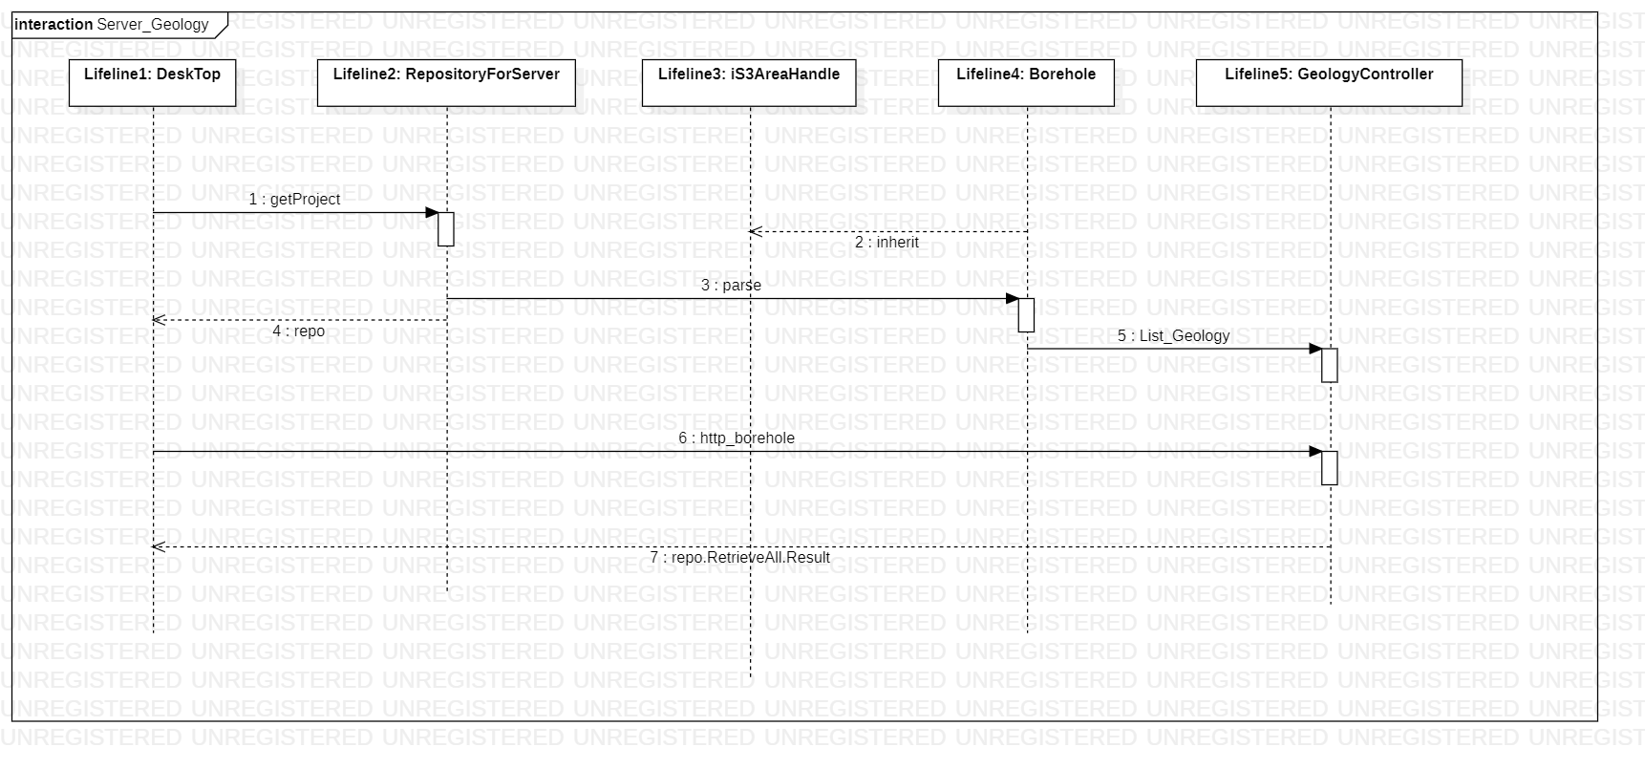

接口

|  |  |  |  |
| --- | --- | --- | --- |
| 请求地址： | /api/Geology/borehole | | |
| 请求方式： | GET | | |
| 请求参数： | 字段 | 类型 | 描述 |
| Project | String | 项目名称 |
| Id | Int | Project ID |
| 成功请求响应： | {  "OBJECTID": "10",  "Name": "Q18XZ13",  "FullName": "1210",  "Description": null,  "StratumSection": 1,  "SectionSequence": 10,  "BoreholeType": "取土兼标贯口",  "TopElevation": 2.89,  "BoreholeLength": 45.3,  "Mileage": null,  "Xcoordinate": 1319.2,  "Ycoordinate": 1455.45,  "BoreholeStratas": [],  "object_id": 10,  "ID": 1210,  "Type": null,  "Default": false,  "ParentID": null,  "DbName": null  } | | |
| 失败请求响应： | null | | |

|  |  |  |  |
| --- | --- | --- | --- |
| 请求地址： | /api/Geology/borehole | | |
| 请求方式： | GET | | |
| 请求参数： | 字段 | 类型 | 描述 |
| Project | String | 项目名称 |
| 成功请求响应： | [  {  "OBJECTID": "1",  "Name": "Q18XZ1",  "FullName": "1201",  "Description": null,  "StratumSection": 1,  "SectionSequence": 1,  "BoreholeType": "取土兼标贯口",  "TopElevation": 2.71,  "BoreholeLength": 35.3,  "Mileage": null,  "Xcoordinate": 1200.55,  "Ycoordinate": 1135.28,  "BoreholeStratas": [],  "object_id": 1,  "ID": 1201,  "Type": null,  "Default": false,  "ParentID": null,  "DbName": null  },  {  "OBJECTID": "2",  "Name": "Q18XZ3",  "FullName": "1202",  "Description": null,  "StratumSection": 1,  "SectionSequence": 2,  "BoreholeType": "取土兼标贯口",  "TopElevation": 2.7,  "BoreholeLength": 40.3,  "Mileage": null,  "Xcoordinate": 1206.81,  "Ycoordinate": 1191.25,  "BoreholeStratas": [],  "object_id": 2,  "ID": 1202,  "Type": null,  "Default": false,  "ParentID": null,  "DbName": null  },  {  "OBJECTID": "3",  "Name": "Q18XC4",  "FullName": "1203",  "Description": null,  "StratumSection": 1,  "SectionSequence": 3,  "BoreholeType": "静力触探孔",  "TopElevation": 2.68,  "BoreholeLength": 40.0,  "Mileage": null,  "Xcoordinate": 1209.3,  "Ycoordinate": 1174.98,  "BoreholeStratas": [],  "object_id": 3,  "ID": 1203,  "Type": null,  "Default": false,  "ParentID": null,  "DbName": null  },  {  "OBJECTID": "4",  "Name": "Q18XC5",  "FullName": "1204",  "Description": null,  "StratumSection": 1,  "SectionSequence": 4,  "BoreholeType": "静力触探孔",  "TopElevation": 2.81,  "BoreholeLength": 40.0,  "Mileage": null,  "Xcoordinate": 1234.63,  "Ycoordinate": 1229.06,  "BoreholeStratas": [],  "object_id": 4,  "ID": 1204,  "Type": null,  "Default": false,  "ParentID": null,  "DbName": null  },  {  "OBJECTID": "5",  "Name": "Q18XZ6",  "FullName": "1205",  "Description": null,  "StratumSection": 1,  "SectionSequence": 5,  "BoreholeType": "取土兼标贯口",  "TopElevation": 2.7,  "BoreholeLength": 40.3,  "Mileage": null,  "Xcoordinate": 1259.16,  "Ycoordinate": 1246.47,  "BoreholeStratas": [],  "object_id": 5,  "ID": 1205,  "Type": null,  "Default": false,  "ParentID": null,  "DbName": null  },  {  "OBJECTID": "6",  "Name": "Q18XC7",  "FullName": "1206",  "Description": null,  "StratumSection": 1,  "SectionSequence": 6,  "BoreholeType": "静力触探孔",  "TopElevation": 2.71,  "BoreholeLength": 45.0,  "Mileage": null,  "Xcoordinate": 1258.45,  "Ycoordinate": 1270.19,  "BoreholeStratas": [],  "object_id": 6,  "ID": 1206,  "Type": null,  "Default": false,  "ParentID": null,  "DbName": null  },  {  "OBJECTID": "7",  "Name": "Q18XZ8",  "FullName": "1207",  "Description": null,  "StratumSection": 1,  "SectionSequence": 7,  "BoreholeType": "取土兼标贯口",  "TopElevation": 2.87,  "BoreholeLength": 40.3,  "Mileage": null,  "Xcoordinate": 1280.42,  "Ycoordinate": 1286.76,  "BoreholeStratas": [],  "object_id": 7,  "ID": 1207,  "Type": null,  "Default": false,  "ParentID": null,  "DbName": null  },  {  "OBJECTID": "8",  "Name": "Q18XC9",  "FullName": "1208",  "Description": null,  "StratumSection": 1,  "SectionSequence": 8,  "BoreholeType": "静力触探孔",  "TopElevation": 3.23,  "BoreholeLength": 50.0,  "Mileage": null,  "Xcoordinate": 1314.68,  "Ycoordinate": 1343.48,  "BoreholeStratas": [],  "object_id": 8,  "ID": 1208,  "Type": null,  "Default": false,  "ParentID": null,  "DbName": null  },  {  "OBJECTID": "9",  "Name": "Q18XZ11",  "FullName": "1209",  "Description": null,  "StratumSection": 1,  "SectionSequence": 9,  "BoreholeType": "取土兼标贯口",  "TopElevation": 2.93,  "BoreholeLength": 45.3,  "Mileage": null,  "Xcoordinate": 1315.64,  "Ycoordinate": 1360.7,  "BoreholeStratas": [],  "object_id": 9,  "ID": 1209,  "Type": null,  "Default": false,  "ParentID": null,  "DbName": null  },  {  "OBJECTID": "10",  "Name": "Q18XZ13",  "FullName": "1210",  "Description": null,  "StratumSection": 1,  "SectionSequence": 10,  "BoreholeType": "取土兼标贯口",  "TopElevation": 2.89,  "BoreholeLength": 45.3,  "Mileage": null,  "Xcoordinate": 1319.2,  "Ycoordinate": 1455.45,  "BoreholeStratas": [],  "object_id": 10,  "ID": 1210,  "Type": null,  "Default": false,  "ParentID": null,  "DbName": null  }  ] | | |
| 失败请求响应： | null | | |

限制条件及出错处理

①后端出错返回null，

②数据库没数据返回空列表。

MonitoringController详细设计

输入项

1. 项目名称：由 HttpRequest 获得（必填）
2. Project ID：由 HttpRequest 获得

逻辑流程

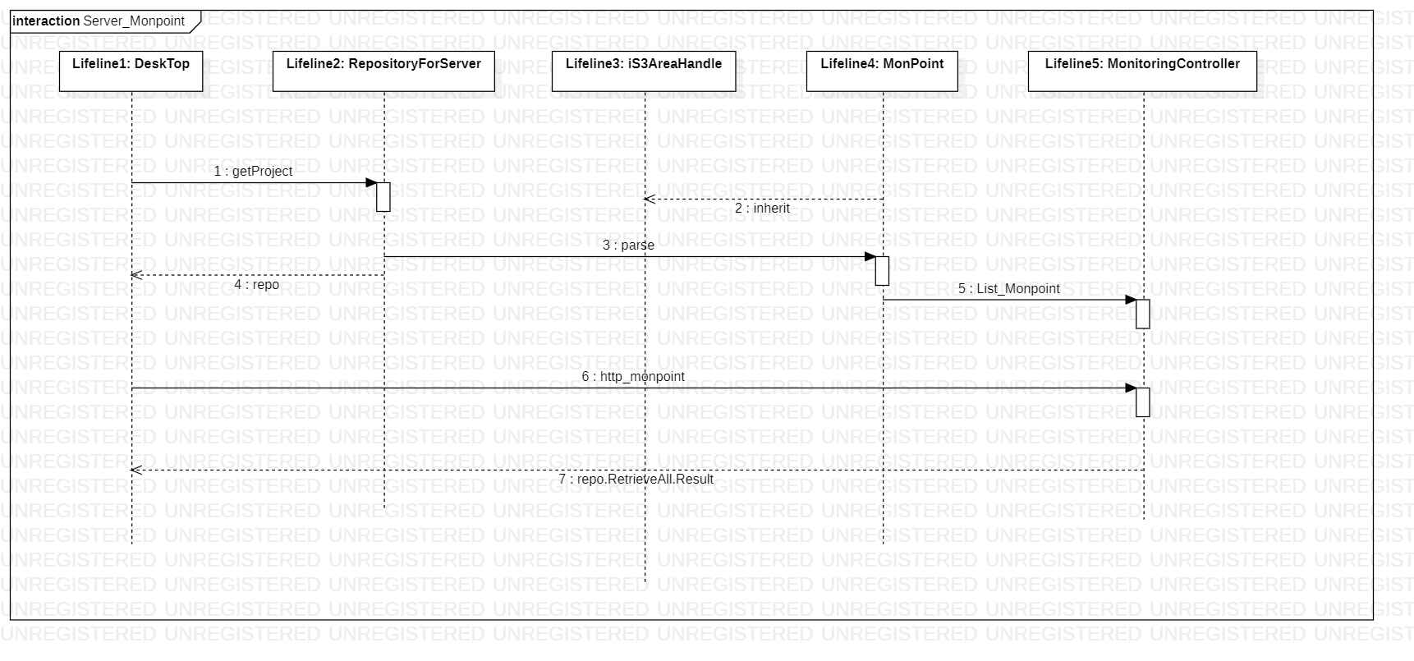

接口

|  |  |  |  |
| --- | --- | --- | --- |
| 请求地址： | /api/monitoring/monpoint | | |
| 请求方式： | Get | | |
| 请求参数： | 字段 | 类型 | 描述 |
|  | project | string | 项目名称 |
|  | id | int | Project ID |
| 成功请求响应： | {  "readingsDict": null,  "monComponentList": [  {  "componentName": "DIPX",  "readings": []  }  ],  "refPointName": "Mon-1",  "distanceX": 0.00,  "distanceY": 0.00,  "distanceZ": 0.00,  "time": "2015-10-02T00:00:00",  "instrumentDetail": "",  "bearingA": 0.00,  "bearingB": 0.00,  "bearingC": 0.00,  "inclinationA": 0.00,  "inclinationB": 0.00,  "inclinationC": 0.00,  "readingSignA": "",  "readingSignB": "",  "readingSignC": "",  "componentCount": 1,  "componentNames": "DIPX",  "remarks": "",  "contractor": "",  "fileName": "",  "object_id": 1,  "ID": 1,  "Name": "Mon-1",  "Description": "双倾角支点",  "FullName": "1",  "Type": null,  "Default": false,  "ParentID": null,  "DbName": null  } | | |
| 失败请求响应： | null | | |

|  |  |  |  |
| --- | --- | --- | --- |
| 请求地址： | /api/monitoring/monpoint | | |
| 请求方式： | Get | | |
| 请求参数： | 字段 | 类型 | 描述 |
|  | project | string | 项目名称 |
| 成功请求响应： | [  {  "readingsDict": null,  "monComponentList": null,  "refPointName": "Mon-1",  "distanceX": 0.00,  "distanceY": 0.00,  "distanceZ": 0.00,  "time": "2015-10-02T00:00:00",  "instrumentDetail": "",  "bearingA": 0.00,  "bearingB": 0.00,  "bearingC": 0.00,  "inclinationA": 0.00,  "inclinationB": 0.00,  "inclinationC": 0.00,  "readingSignA": "",  "readingSignB": "",  "readingSignC": "",  "componentCount": 1,  "componentNames": "DIPX",  "remarks": "",  "contractor": "",  "fileName": "",  "object_id": 1,  "ID": 1,  "Name": "Mon-1",  "Description": "双倾角支点",  "FullName": "1",  "Type": null,  "Default": false,  "ParentID": null,  "DbName": null  },  {  "readingsDict": null,  "monComponentList": null,  "refPointName": "Mon-2",  "distanceX": 0.00,  "distanceY": 0.00,  "distanceZ": 0.00,  "time": "2015-08-29T00:00:00",  "instrumentDetail": "",  "bearingA": 0.00,  "bearingB": 0.00,  "bearingC": 0.00,  "inclinationA": 0.00,  "inclinationB": 0.00,  "inclinationC": 0.00,  "readingSignA": "",  "readingSignB": "",  "readingSignC": "",  "componentCount": 1,  "componentNames": "DIPX",  "remarks": "",  "contractor": "",  "fileName": "",  "object_id": 2,  "ID": 2,  "Name": "Mon-2",  "Description": "双倾角支点",  "FullName": "2",  "Type": null,  "Default": false,  "ParentID": null,  "DbName": null  },  {  "readingsDict": null,  "monComponentList": null,  "refPointName": "Mon-3",  "distanceX": 0.00,  "distanceY": 0.00,  "distanceZ": 0.00,  "time": "2015-10-02T00:00:00",  "instrumentDetail": "",  "bearingA": 0.00,  "bearingB": 0.00,  "bearingC": 0.00,  "inclinationA": 0.00,  "inclinationB": 0.00,  "inclinationC": 0.00,  "readingSignA": "",  "readingSignB": "",  "readingSignC": "",  "componentCount": 1,  "componentNames": "DIPX",  "remarks": "",  "contractor": "",  "fileName": "",  "object_id": 3,  "ID": 3,  "Name": "Mon-3",  "Description": "双倾角支点",  "FullName": "3",  "Type": null,  "Default": false,  "ParentID": null,  "DbName": null  },  {  "readingsDict": null,  "monComponentList": null,  "refPointName": "Mon-4",  "distanceX": 0.00,  "distanceY": 0.00,  "distanceZ": 0.00,  "time": "2015-10-02T00:00:00",  "instrumentDetail": "",  "bearingA": 0.00,  "bearingB": 0.00,  "bearingC": 0.00,  "inclinationA": 0.00,  "inclinationB": 0.00,  "inclinationC": 0.00,  "readingSignA": "",  "readingSignB": "",  "readingSignC": "",  "componentCount": 1,  "componentNames": "DIPX",  "remarks": "",  "contractor": "",  "fileName": "",  "object_id": 4,  "ID": 4,  "Name": "Mon-4",  "Description": "双倾角支点",  "FullName": "4",  "Type": null,  "Default": false,  "ParentID": null,  "DbName": null  },  {  "readingsDict": null,  "monComponentList": null,  "refPointName": "Mon-5",  "distanceX": 0.00,  "distanceY": 0.00,  "distanceZ": 0.00,  "time": "2015-08-29T00:00:00",  "instrumentDetail": "",  "bearingA": 0.00,  "bearingB": 0.00,  "bearingC": 0.00,  "inclinationA": 0.00,  "inclinationB": 0.00,  "inclinationC": 0.00,  "readingSignA": "",  "readingSignB": "",  "readingSignC": "",  "componentCount": 1,  "componentNames": "DIPX",  "remarks": "",  "contractor": "",  "fileName": "",  "object_id": 5,  "ID": 5,  "Name": "Mon-5",  "Description": "双倾角支点",  "FullName": "5",  "Type": null,  "Default": false,  "ParentID": null,  "DbName": null  },  {  "readingsDict": null,  "monComponentList": null,  "refPointName": "Mon-6",  "distanceX": 0.00,  "distanceY": 0.00,  "distanceZ": 0.00,  "time": "2015-10-02T00:00:00",  "instrumentDetail": "",  "bearingA": 0.00,  "bearingB": 0.00,  "bearingC": 0.00,  "inclinationA": 0.00,  "inclinationB": 0.00,  "inclinationC": 0.00,  "readingSignA": "",  "readingSignB": "",  "readingSignC": "",  "componentCount": 1,  "componentNames": "DIPX",  "remarks": "",  "contractor": "",  "fileName": "",  "object_id": 6,  "ID": 6,  "Name": "Mon-6",  "Description": "双倾角支点",  "FullName": "6",  "Type": null,  "Default": false,  "ParentID": null,  "DbName": null  },  {  "readingsDict": null,  "monComponentList": null,  "refPointName": "Mon-7",  "distanceX": 0.00,  "distanceY": 0.00,  "distanceZ": 0.00,  "time": "2015-10-02T00:00:00",  "instrumentDetail": "",  "bearingA": 0.00,  "bearingB": 0.00,  "bearingC": 0.00,  "inclinationA": 0.00,  "inclinationB": 0.00,  "inclinationC": 0.00,  "readingSignA": "",  "readingSignB": "",  "readingSignC": "",  "componentCount": 1,  "componentNames": "DIPX",  "remarks": "",  "contractor": "",  "fileName": "",  "object_id": 7,  "ID": 7,  "Name": "Mon-7",  "Description": "双倾角支点",  "FullName": "7",  "Type": null,  "Default": false,  "ParentID": null,  "DbName": null  },  {  "readingsDict": null,  "monComponentList": null,  "refPointName": "Mon-8",  "distanceX": 0.00,  "distanceY": 0.00,  "distanceZ": 0.00,  "time": "2015-08-29T00:00:00",  "instrumentDetail": "",  "bearingA": 0.00,  "bearingB": 0.00,  "bearingC": 0.00,  "inclinationA": 0.00,  "inclinationB": 0.00,  "inclinationC": 0.00,  "readingSignA": "",  "readingSignB": "",  "readingSignC": "",  "componentCount": 1,  "componentNames": "DIPX",  "remarks": "",  "contractor": "",  "fileName": "",  "object_id": 8,  "ID": 8,  "Name": "Mon-8",  "Description": "双倾角支点",  "FullName": "8",  "Type": null,  "Default": false,  "ParentID": null,  "DbName": null  },  {  "readingsDict": null,  "monComponentList": null,  "refPointName": "Mon-9",  "distanceX": 0.00,  "distanceY": 0.00,  "distanceZ": 0.00,  "time": "2015-10-02T00:00:00",  "instrumentDetail": "",  "bearingA": 0.00,  "bearingB": 0.00,  "bearingC": 0.00,  "inclinationA": 0.00,  "inclinationB": 0.00,  "inclinationC": 0.00,  "readingSignA": "",  "readingSignB": "",  "readingSignC": "",  "componentCount": 1,  "componentNames": "DIPX",  "remarks": "",  "contractor": "",  "fileName": "",  "object_id": 9,  "ID": 9,  "Name": "Mon-9",  "Description": "双倾角支点",  "FullName": "9",  "Type": null,  "Default": false,  "ParentID": null,  "DbName": null  },  {  "readingsDict": null,  "monComponentList": null,  "refPointName": "Mon-10",  "distanceX": 0.00,  "distanceY": 0.00,  "distanceZ": 0.00,  "time": "2015-10-02T00:00:00",  "instrumentDetail": "",  "bearingA": 0.00,  "bearingB": 0.00,  "bearingC": 0.00,  "inclinationA": 0.00,  "inclinationB": 0.00,  "inclinationC": 0.00,  "readingSignA": "",  "readingSignB": "",  "readingSignC": "",  "componentCount": 1,  "componentNames": "DIPX",  "remarks": "",  "contractor": "",  "fileName": "",  "object_id": 10,  "ID": 10,  "Name": "Mon-10",  "Description": "双倾角支点",  "FullName": "10",  "Type": null,  "Default": false,  "ParentID": null,  "DbName": null  },  {  "readingsDict": null,  "monComponentList": null,  "refPointName": "Mon-11",  "distanceX": 0.00,  "distanceY": 0.00,  "distanceZ": 0.00,  "time": "2015-08-29T00:00:00",  "instrumentDetail": "",  "bearingA": 0.00,  "bearingB": 0.00,  "bearingC": 0.00,  "inclinationA": 0.00,  "inclinationB": 0.00,  "inclinationC": 0.00,  "readingSignA": "",  "readingSignB": "",  "readingSignC": "",  "componentCount": 1,  "componentNames": "DIPX",  "remarks": "",  "contractor": "",  "fileName": "",  "object_id": 11,  "ID": 11,  "Name": "Mon-11",  "Description": "双倾角支点",  "FullName": "11",  "Type": null,  "Default": false,  "ParentID": null,  "DbName": null  },  {  "readingsDict": null,  "monComponentList": null,  "refPointName": "Mon-12",  "distanceX": 0.00,  "distanceY": 0.00,  "distanceZ": 0.00,  "time": "2015-10-02T00:00:00",  "instrumentDetail": "",  "bearingA": 0.00,  "bearingB": 0.00,  "bearingC": 0.00,  "inclinationA": 0.00,  "inclinationB": 0.00,  "inclinationC": 0.00,  "readingSignA": "",  "readingSignB": "",  "readingSignC": "",  "componentCount": 1,  "componentNames": "DIPX",  "remarks": "",  "contractor": "",  "fileName": "",  "object_id": 12,  "ID": 12,  "Name": "Mon-12",  "Description": "双倾角支点",  "FullName": "12",  "Type": null,  "Default": false,  "ParentID": null,  "DbName": null  },  {  "readingsDict": null,  "monComponentList": null,  "refPointName": "Mon-13",  "distanceX": 0.00,  "distanceY": 0.00,  "distanceZ": 0.00,  "time": "2015-10-02T00:00:00",  "instrumentDetail": "",  "bearingA": 0.00,  "bearingB": 0.00,  "bearingC": 0.00,  "inclinationA": 0.00,  "inclinationB": 0.00,  "inclinationC": 0.00,  "readingSignA": "",  "readingSignB": "",  "readingSignC": "",  "componentCount": 1,  "componentNames": "DIPX",  "remarks": "",  "contractor": "",  "fileName": "",  "object_id": 13,  "ID": 13,  "Name": "Mon-13",  "Description": "双倾角支点",  "FullName": "13",  "Type": null,  "Default": false,  "ParentID": null,  "DbName": null  },  {  "readingsDict": null,  "monComponentList": null,  "refPointName": "Mon-14",  "distanceX": 0.00,  "distanceY": 0.00,  "distanceZ": 0.00,  "time": "2015-08-29T00:00:00",  "instrumentDetail": "",  "bearingA": 0.00,  "bearingB": 0.00,  "bearingC": 0.00,  "inclinationA": 0.00,  "inclinationB": 0.00,  "inclinationC": 0.00,  "readingSignA": "",  "readingSignB": "",  "readingSignC": "",  "componentCount": 1,  "componentNames": "DIPX",  "remarks": "",  "contractor": "",  "fileName": "",  "object_id": 14,  "ID": 14,  "Name": "Mon-14",  "Description": "双倾角支点",  "FullName": "14",  "Type": null,  "Default": false,  "ParentID": null,  "DbName": null  }  ] | | |
| 失败请求响应： | null | | |

限制条件及出错处理

①后端出错返回null，

②数据库没数据返回空列表。